Passive Footprinting (By Tayyab)

***Grammarly***

**Tasks**

**1. Website Analysis:**

**Email:** support@grammarly.com

**Address:** San Francisco, California, United States

**Website:**

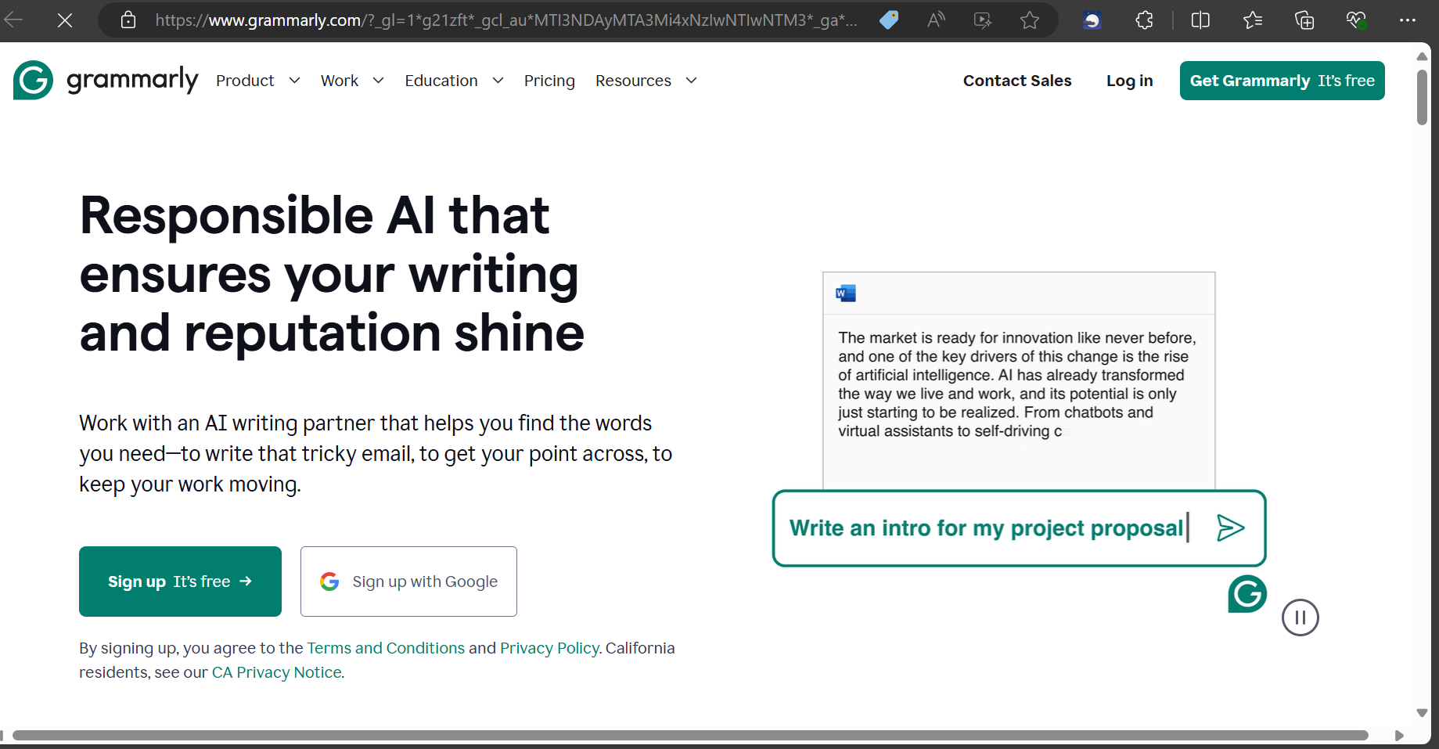

**Domain Information:**

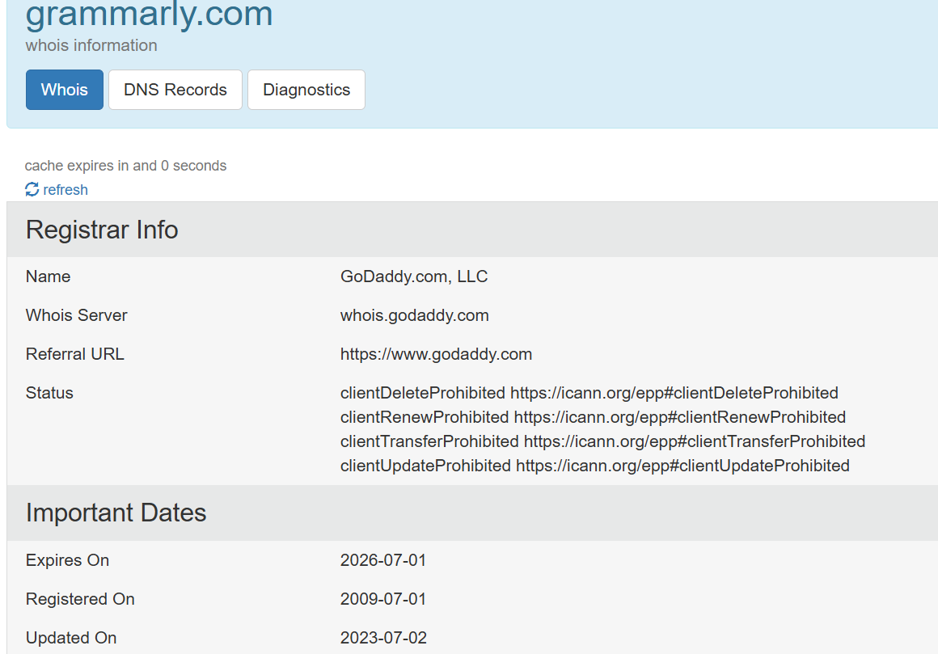

**Team Members (source:** [Careers at Grammarly](https://www.grammarly.com/jobs)**)**

Head of growth: Shanik Patel

Product marketing: Nicole Sim

Software Engineer: Umayah Abdennabi

Research Scientist: Maria Nadejde

Sales Representative: Greg Zapletnikov

**News:** 

**2. Social Media Footprinting:**

**LinkedIn:**



**Opportunity:**



**Potential Targets on Linkedin:**





**3. Netcraft Analysis:**

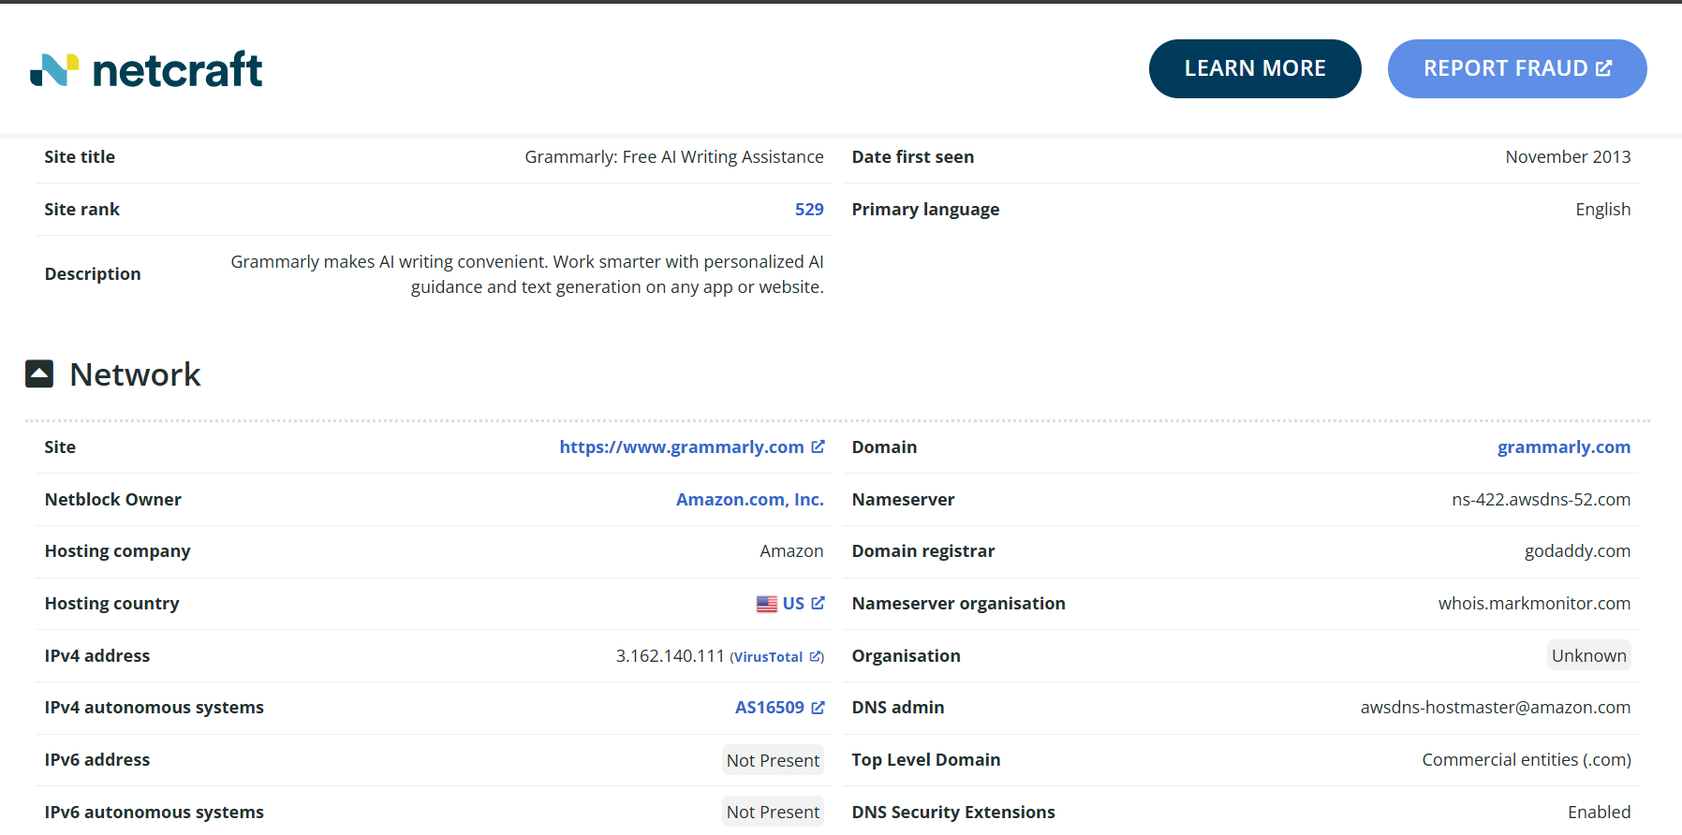

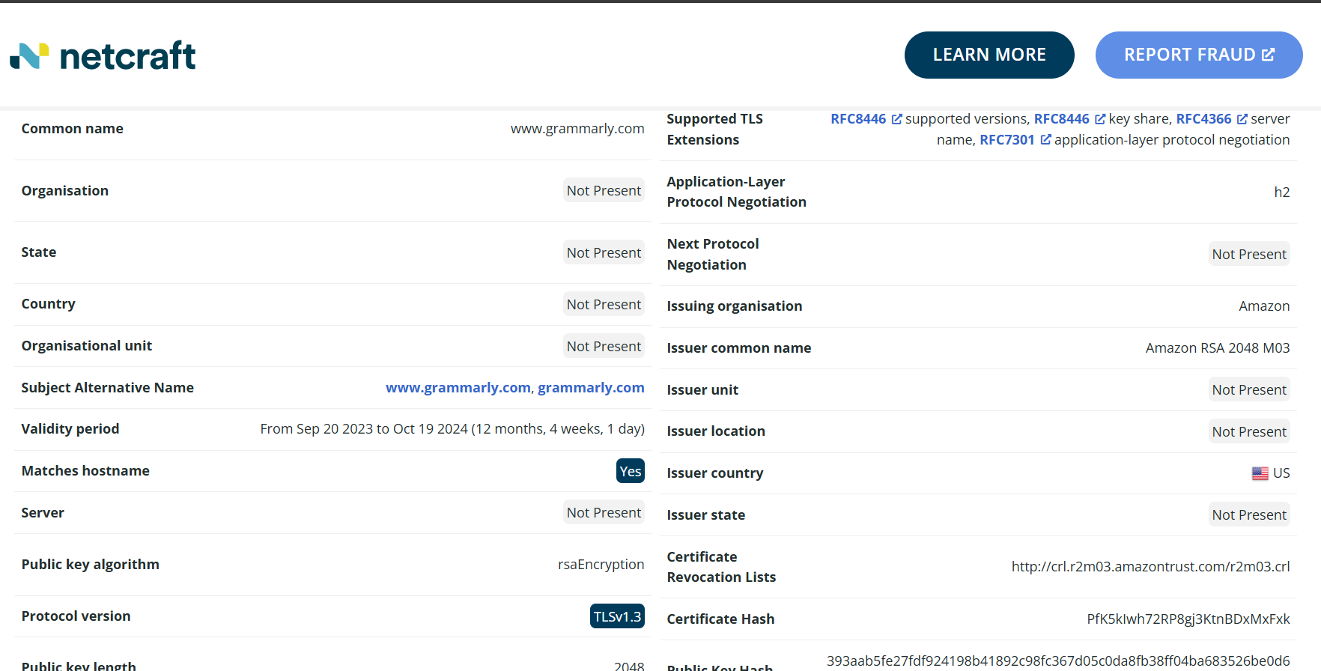

**4. Shodan Search:**

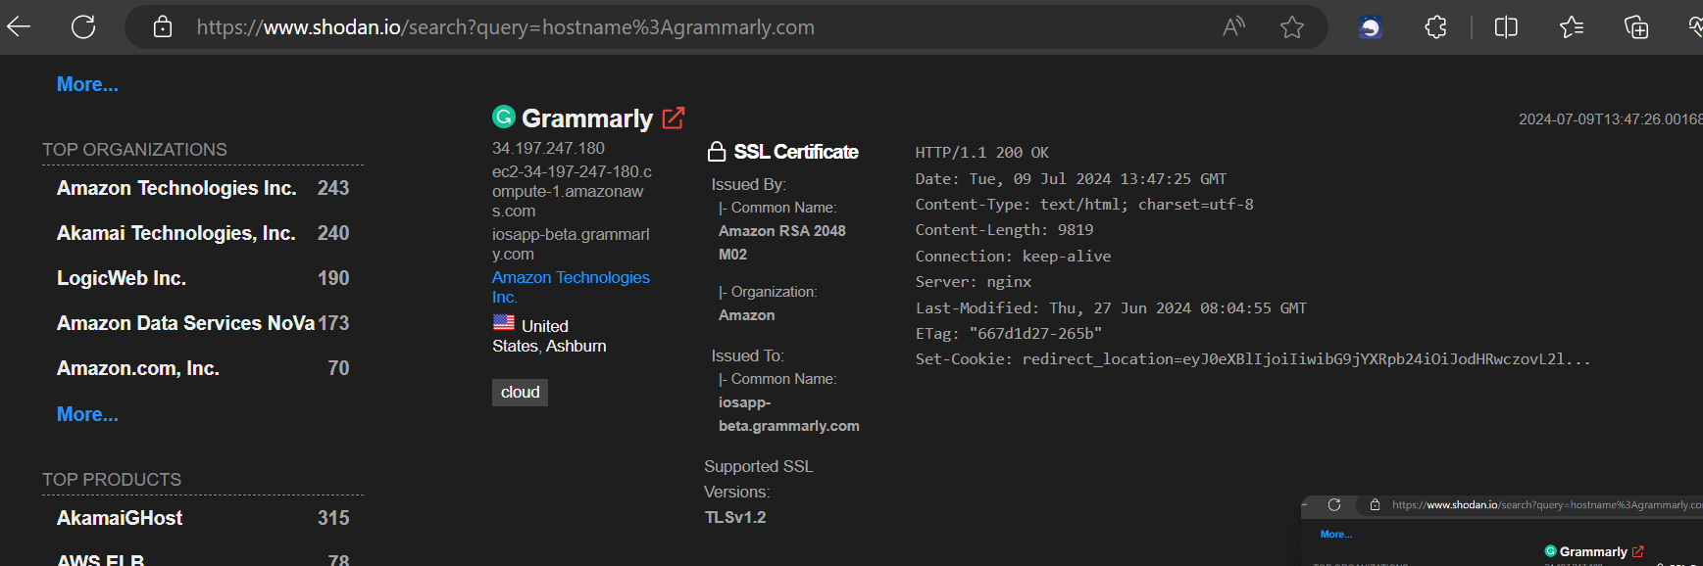

**IP Address:** 34.197.247.180

**Open ports:** 80, 443

**5. Search Engine Queries:**

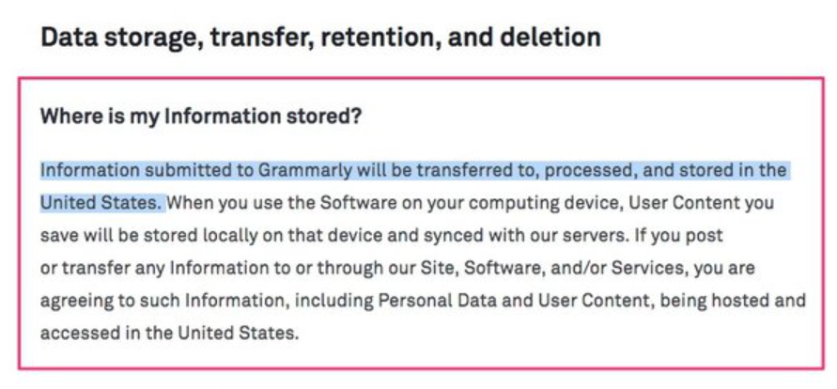

Grammarly Bug Let Snoops Read What You Wrote, Typos and All (Source: [Gizmodo.com)](https://gizmodo.com/grammarly-bug-let-snoops-read-everything-you-wrote-onli-1822740378)

**6. Business Directories:**

**Ratings & Reviews:**

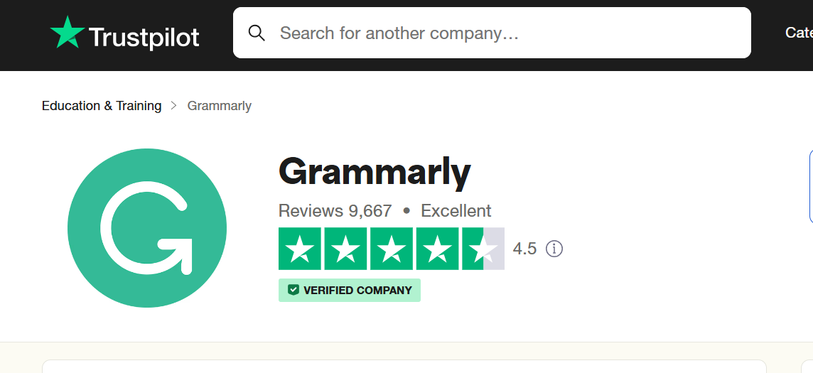

**Yelp:** No information.

**7. Job Boards:**

**Grammarly Site:**

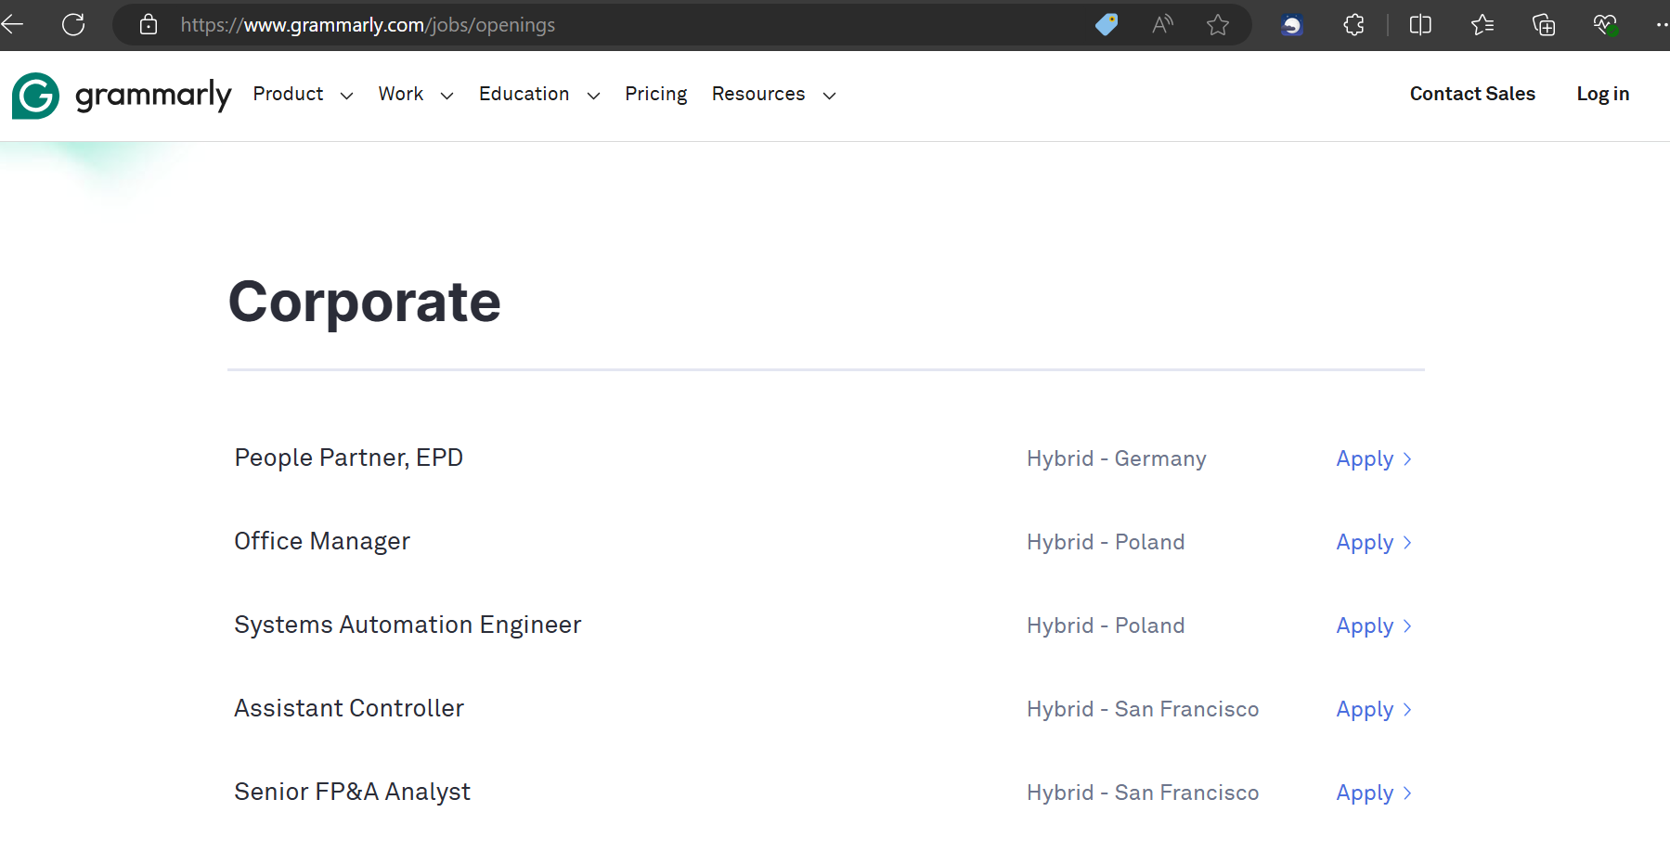

**Job postings on Linkedin:**

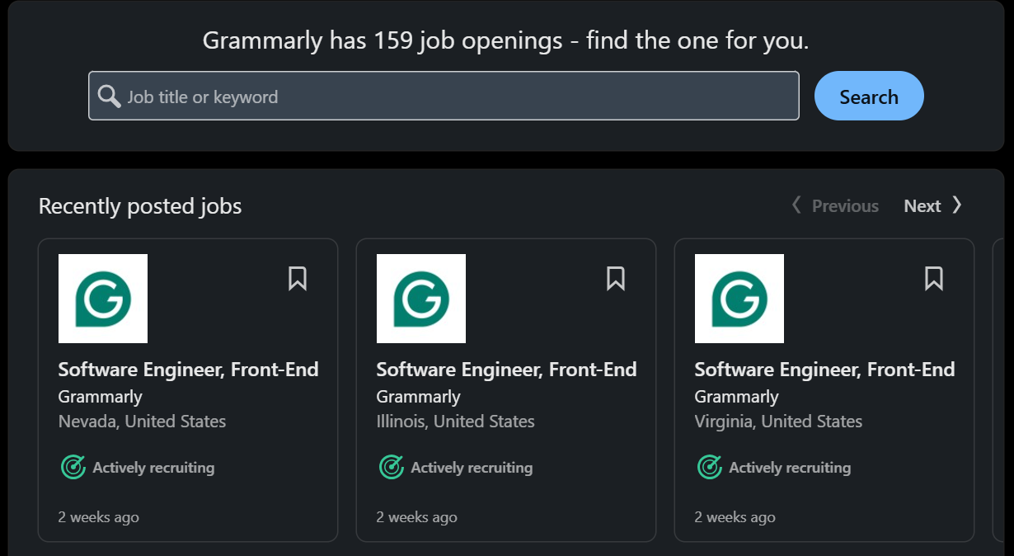



**8. Technical Footprinting:**

**Github:**

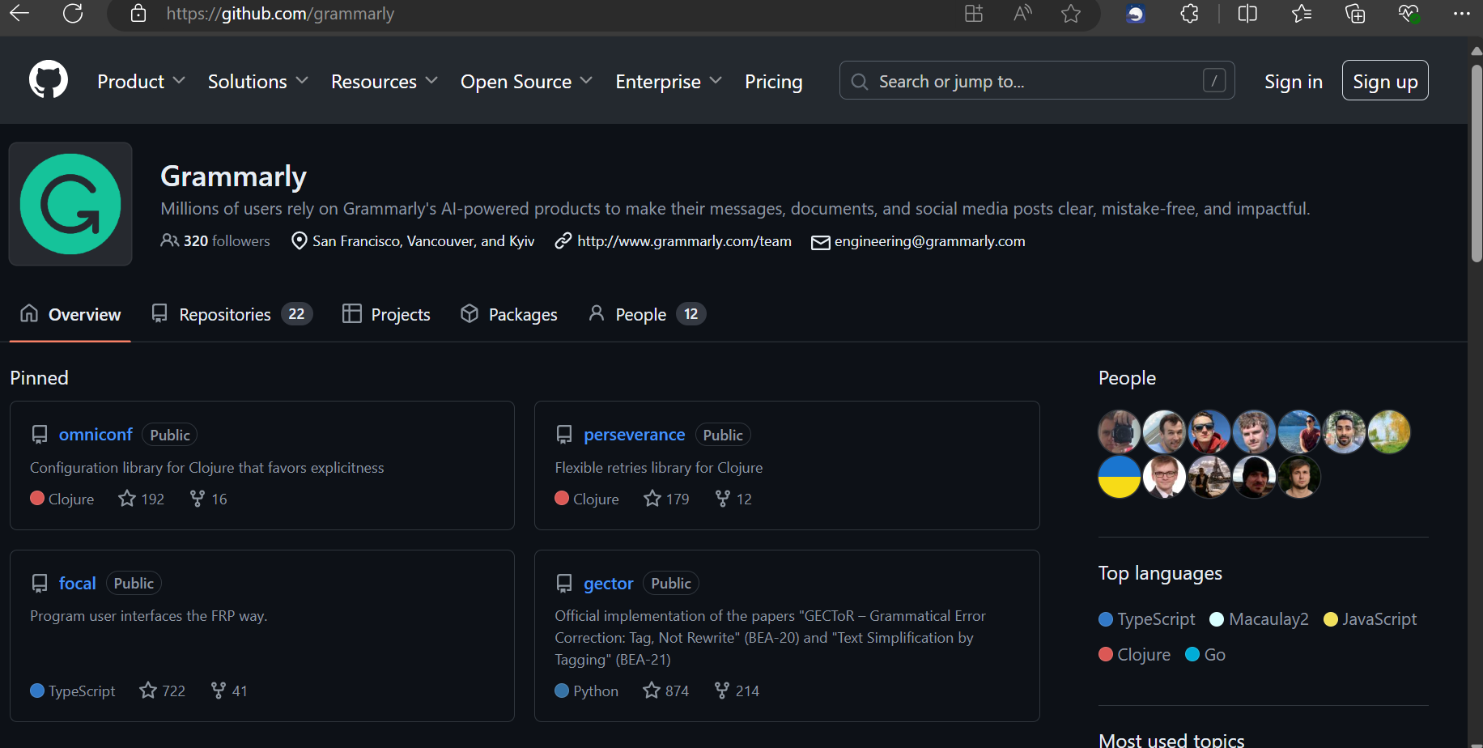

**Grammarly API:**



**9. Financial and Legal Filings:**

**Board Members:**

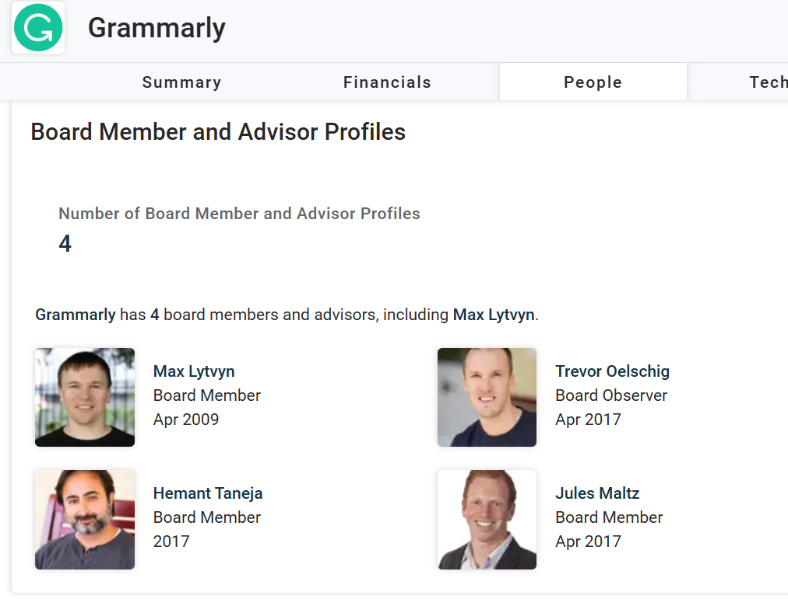

**Financial Reports:**

